M E D I A A L E R T
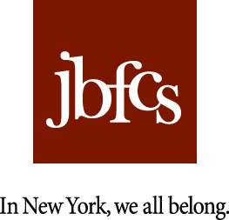
Russell Simmons
visits
JBFCS Programs in action
inspiring New York City Youth

This April, Jewish Board of Family & Children’s Services (JBFCS) will host its Annual Spring Benefit, Made in New York, honoring JBFCS Board of Trustees Chairman, John A Herrmann, JBFCS Vice President David F. Everett and Russell Simmons, Founder of Def Jam, Co-Founder of the Foundation for Ethnic Understanding (FFEU), and creator of fashion lines Phat Farm, Argyleculture, American Classics.
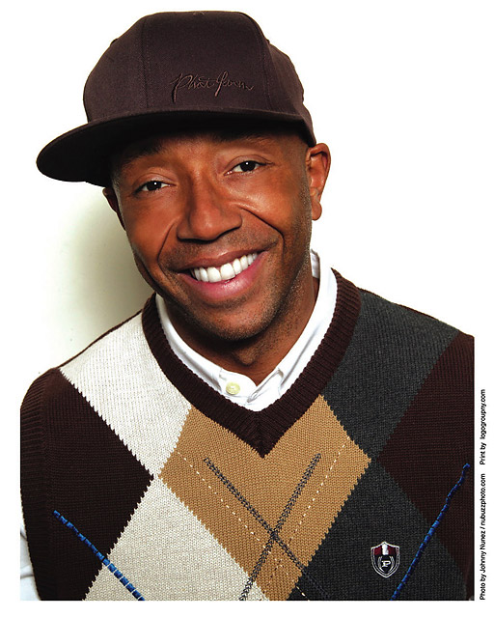
In anticipation of his being honored by the nonprofit organization, Russell Simmons, along with Rabbi Marc Schneier with whom he co-founded FFEU, spent the day touring two JBFCS facilities and meeting with adolescents that these institutions serve.

Mr. Simmons and Rabbi Schneier met with Break-Free Program, a mental health and substance abuse program for a diverse group of teens that includes an alternative high school, and B’not Chaya Academy, an alternative Yeshiva high school for at-risk Orthodox girls. The young men and women who are part of these powerful programs shared their stories, detailing their past challenges at home, school and on the streets; at times heart-wrenching, many of these young people shared the extraordinary challenges they have experienced in their short lives. Looking forward, the youth also spoke of their current personal objectives and how JBFCS has helped in turning their lives around.

Throughout the day, Mr. Simmons engaged in conversations with the participating youth in each program as well as the staff, identifying role models and mentors and encouraging the adolescents to make ‘smart choices’ and walk away from those who may prove to be a negative influence in their lives and ‘drag them down.’ Acknowledging that such choices are difficult to make at any stage in life – especially as a teen – Mr. Simmons congratulated them on their resilience and courage. Throughout the course of the day, Mr. Simmons communicated his experiences with some 315,000 Twitter followers (http://twitter.com/uNcleRUSH).

Made in New York will be held at Guastavino’s on April 21, 2010 in New York City with proceeds benefitting the JBFCS’ 185 community-based programs, residential facilities, and day-treatment centers that annually serve over 65,000 New Yorkers-in-need of all faiths, races and cultures. For further event details and information on JBFCS, please visit www.jbfcs.org.

ABOUT JBFCS: JBFCS has been a trailblazer in treating social problems for more than a century. Today, JBFCS is one of the nation’s largest and most respected nonprofit mental health and social service agencies— every night, over 1,000 individuals call a JBFCS residence home. The work of JBFCS is built upon a network of over 2,200 professionals, including social workers, licensed psychologists, and psychiatrists, as well as a cadre of clinical support personnel in continuing day treatment and residential treatment centers, and a corps of over 2,200 dedicated volunteers. JBFCS provides a comprehensive network of mental health and social services to promote well-being, resilience and self-sufficiency for individuals and families in need in the New York metropolitan area. As leaders in the field of human services, the JBFCS mission is clear— 175 social service programs. 1 mission. To get help to those who need it.

PRESS CONTACT: Norah Lawlor JBFCS CONTACT: Jo Gonsalves
Lawlor Media Group JBFCS Director of Communications
Tel: (212) 967-6900 Tel: (212) 632-4663
Norah@lawlormediagroup.com jgonsalves@jbfcs.org
www.lawlormediagroup.com www.jbfcs.org

